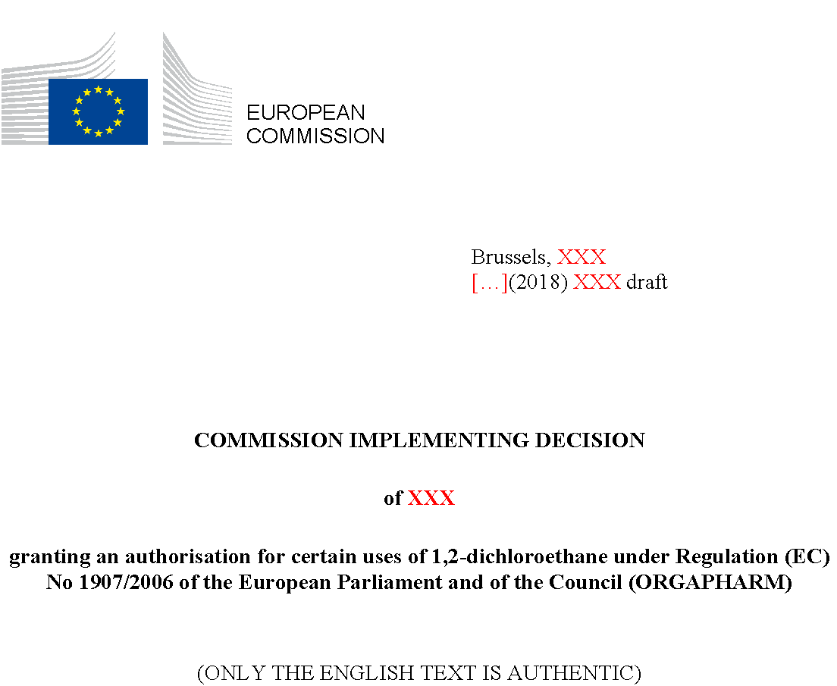

COMMISSION IMPLEMENTING DECISION
of XXX
granting an authorisation for certain uses of 1,2-dichloroethane under Regulation (EC) No 1907/2006 of the European Parliament and of the Council (ORGAPHARM)
(ONLY THE ENGLISH TEXT IS AUTHENTIC)
THE EUROPEAN COMMISSION,
Having regard to the Treaty on the Functioning of the European Union,
Having regard to Regulation (EC) No 1907/2006 of the European Parliament and of the Council of 18 December 2006 concerning the Registration, Evaluation, Authorisation and Restriction of Chemicals (REACH), establishing a European Chemicals Agency, amending Directive 1999/45/EC and repealing Council Regulation (EEC) No 793/93 and Commission Regulation (EC) No 1488/94 as well as Council Directive 76/769/EEC and Commission Directives 91/155/EEC, 93/67/EEC, 93/105/EC and 2000/21/EC, and in particular Article 64(8) thereof,
Whereas:
- 1,2-dichloroethane (EDC) is listed in Annex XIV to Regulation (EC) No 1907/2006 and is therefore subject to the authorisation requirement referred to in Article 56(1)(a) of that Regulation.
- On 20 May 2016, 3M France SAS submitted, in accordance with Article 62 of Regulation (EC) No 1907/2006, an application for authorisation for the use of EDC as process solvent in the manufacture of two Active Pharmaceutical Ingredients: Flecainide acetate ('use 1') and Nefopam hydrochloride ('use 2'). On 3 October 2016, a legal entity change was notified to the European Chemicals Agency (ECHA) and the application was transferred to ORGAPHARM ('the applicant').
- On 8 June 2017, the Commission received the opinions of the Committee for Risk Assessment (RAC) and the Committee for Socio-economic Analysis (SEAC) of the European Chemicals Agency on the application pursuant to the second subparagraph of Article 64(5) of Regulation (EC) No 1907/2006.
- In its opinions, RAC confirmed that for both uses it is not possible to determine a derived no-effect level (DNEL) for the carcinogenic properties of EDC in accordance with Section 6.4 of Annex I to Regulation (EC) No 1907/2006 and that therefore EDC is a non-threshold substance. In accordance with Article 60(3)(a) of Regulation (EC) No 1907/2006, Article 60(2) of that Regulation does not apply to that substance, and therefore an authorisation may only be granted on the basis of Article 60(4) of Regulation (EC) No 1907/2006.
- In its opinions, RAC concluded that the risk management measures and operational conditions as described in the application are appropriate and effective in limiting the risk to workers and the general population that could potentially be exposed via the environment. However, due to the heavy reliance on high effective personal protective equipment (PPE) to reduce worker exposure and the amount of emissions to air, RAC recommended to implement a leak detection and repair programme.
- In its opinions, SEAC concluded that the overall socio-economic benefits arising from each of the two uses of EDC applied for outweigh the risk to human health or the environment arising from each of those uses and that there are no suitable alternative substances or technologies in terms of their technical and economic feasibility for the applicant before the sunset date. The Commission, having evaluated the SEAC's assessments, concurs with these conclusions.
- Therefore, in accordance with Article 60(4) of Regulation (EC) No 1907/2006, it is appropriate to authorise the two uses of EDC applied for, provided that the risk management measures and operational conditions described in the application and in particular in the chemical safety report are fully applied.
- In its opinions, SEAC recommended the review period referred to in Article 60(9)(e) of Regulation (EC) No 1907/2006 to be set at seven years for both uses applied for. The Commission takes into account the relevant elements from RAC's and SEAC's assessments, and in particular, the risk of continued use of the substance and its conclusion that the implemented risk management measures and operational conditions are appropriate and effective in limiting the risk, the applicant's lengthy research and development activities and its plan to continue the search for a substitute, the time necessary for industrialisation of a potential alternative and for a regulatory approval under the medicinal products legislation, the level of socio-economic benefits and costs associated with the continued use, as well as the conclusion that the socio-economic benefits of continued use clearly outweigh the risk to human health. The Commission concurs with SEAC's recommendations.
- Therefore, the Commission considers appropriate that, as regards the two uses of EDC applied for, the review period referred to in Article 60(9)(e) of Regulation (EC) No 1907/2006 is set at seven years as from the sunset date set out in Annex XIV to Regulation (EC) No 1907/2006.
- The language used for the description of the risk management measures and operational conditions included in the application for authorisation may be different from the official language of the Member State where the uses take place. Therefore, in order to facilitate the enforcement of the authorisation, it is appropriate to include a monitoring arrangement requiring the authorisation holder to submit, upon request, a succinct summary of those risk management measures and operational conditions in an official language of the Member State concerned.
- This Decision does not affect the obligation of the authorisation holder to ensure that the use does not adversely affect human health or the environment pursuant to Article 1(3) of Regulation (EC) No 1907/2006. Furthermore, it does not affect either the obligation of the authorisation holder to ensure that the exposure to the substance is reduced to as low a level as is technically and practically possible pursuant to Article 60(10) of Regulation (EC) No 1907/2006 or the obligation of the employer to reduce the use of a carcinogen or mutagen at the place of work, in particular by replacing it, in so far as is technically possible in accordance with Article 4(1) of Directive 2004/37/EC of the European Parliament and of the Council, or to prevent and reduce exposure in accordance with Article 5 of that Directive. In addition, this Decision is without prejudice to the application of the Union Directives in the area of health and safety at work, in particular Council Directive 89/391/EEC, Council Directive 98/24, Directive 2004/37, Council Directive 92/85/EEC and Council Directive 94/33/EC.
- This Decision is without prejudice to any obligation to comply with emission limit values set in accordance with Directive 2010/75/EU of the European Parliament and of the Council and Directive 2008/50/EC of the European Parliament and of the Council, as well as with emission limit values set to achieve compliance with the environmental quality standards established both in Directive 2008/105/EC of the European Parliament and of the Council and by Member States in accordance with Directive 2000/60/EC of the European Parliament and of the Council. Compliance with the provisions of this Decision should not necessarily result in compliance with emission limit values or environmental quality standards under other Union legislation, which may include separate or more onerous requirements.
- The measures provided for in this Decision are in accordance with the opinion of the Committee established under Article 133 of Regulation (EC) No 1907/2006,
HAS ADOPTED THIS DECISION:
Article 1
An authorisation is granted in accordance with Article 60(4) of Regulation (EC) No 1907/2006 for the following uses of 1,2-dichloroethane (EC No. 203-458-1; CAS No. 107-06-2) provided that the risk management measures and operational conditions described in the chemical safety report submitted pursuant to Article 62(4)(d) of that Regulation are fully applied:
Authorisation number | - Authorised use
REACH/18/X/0 | - Use of 1,2-dichloroethane as process solvent in the manufacture of an Active Pharmaceutical Ingredient: Flecainide acetate
REACH/18/X/1 | - Use of 1,2-dichloroethane as process solvent in the manufacture of an Active Pharmaceutical Ingredient: Nefopam hydrochloride
Article 2
- As regards the authorised uses of 1,2-dichloroethane, the review period referred to in Article 60(9)(e) of Regulation (EC) No 1907/2006 shall expire on 22 November 2024.
- The authorisations REACH/18/X/0 and REACH/18/X/1 shall cease to be valid on 22 November 2024 in case the review report referred to in Article 61(1) of Regulation (EC) No 1907/2006 has not been submitted by 22 May 2023, unless a decision to withdraw the authorisation is adopted earlier in application of Article 61(2) and (3) of that Regulation.
Article 3
The following monitoring arrangements shall apply:
  - the authorisation holder shall conduct regular occupational exposure measurements related to the uses described in Article 1. Those measurements shall:
(i) take place at least annually;
(ii) be based on relevant standard methodologies or protocols with a sufficiently low detection limit;
(iii) comprise both personal and static (where appropriate) inhalation exposure sampling and be representative of the range of tasks with possible exposure to 1,2-dichloroethane and of the total number of workers potentially exposed. The planned maintenance-related tasks shall be included;
(iv) include contextual information about the tasks with possible exposure to 1,2-dichloroethane;
  - the authorisation holder shall implement a leak detection and repair program that has to be included in the planned maintenance activities, to identify and reduce sources of fugitive emissions;
  - the authorisation holder shall investigate how to enhance the risk management measures related to canalised air emissions with a view to reduce these emissions further and implement these enhanced risk management measures where possible, with a particular focus on emissions from the ovens;
  - the information gathered in the measurements referred to in point (a) shall be used to regularly review the appropriateness and effectiveness of the risk management measures and operational conditions and to take actions, as appropriate, to further reduce workers' exposure to 1,2-dichloroethane. This information shall also be used to review the effectiveness of the leak detection and repair programme referred to in (b), in particular concerning workers contributing scenarios 2 and 3;
  - the results of the measurements referred to in point (a), as well as the outcome and conclusions of the leak detection and repair programme in accordance with point (b), the investigations how to enhance the risk management measures in accordance with point (c), the review and any action taken in accordance with point (d), shall be documented, submitted upon request to the competent authority of the Member State where the authorised use take place and included in the review report referred to in Article 61(1) of Regulation (EC) No 1907/2006.
Article 5
The authorisation holder shall submit, upon request, to the competent authority of the Member State where the authorised use takes place a succinct summary of the applicable risk management measures and operational conditions described in the chemical safety report in an official language of that Member State.
Article 6
This Decision is addressed to ORGAPHARM, Rue du Moulin de la canne, 45300 Pithiviers, France.
Done at Brussels,
For the Commission
Elżbieta BIEŃKOWSKA
Member of the Commission

OJ L 396, 30.12.2006, p. 1.
https://echa.europa.eu/documents/10162/c82dc7d4-87a0-f0ba-cbce-8e7fe0fc03a8 https://echa.europa.eu/documents/10162/678b667e-a15e-58e5-ff36-d0702f69f12c
http://ec.europa.eu/docsroom/documents/24102 http://ec.europa.eu/docsroom/documents/24103
Directive 2004/37/EC of the European Parliament and of the Council of 29 April 2004 on the protection of workers from the risks related to exposure to carcinogens or mutagens at work (Sixth individual Directive within the meaning of Article 16(1) of Council Directive 89/391/EEC) (OJ L 158, 30.4.2004, p. 50).
Council Directive 89/391/EEC of 12 June 1989 on the introduction of measures to encourage improvements in the safety and health of workers at work (OJ L 183, 29.6.1989, p. 1).
Council Directive 98/24/EC of 7 April 1998 on the protection of the health and safety of workers from the risks related to chemical agents at work (fourteenth individual Directive within the meaning of Article 16(1) of Directive 89/391/EEC) (OJ L 131, 5.5.1998, p. 11).
Council Directive 92/85/EEC of 19 October 1992 on the introduction of measures to encourage improvements in the safety and health at work of pregnant workers and workers who have recently given birth or are breastfeeding (tenth individual Directive within the meaning of Article 16 ( 1 ) of Directive 89/ 391 / EEC) (OJ L 348, 28.11.1992, p. 1).
Council Directive 94/33/EC of 22 June 1994 on the protection of young people at work (OJ L 216, 20.8.1994, p. 12).
Directive 2010/75/EU of the European Parliament and of the Council of 24 November 2010 on industrial emissions (integrated pollution prevention and control)(OJ L 334, 17.12.2010, p. 17).
Directive 2008/50/EC of the European Parliament and of the Council of 21 May 2008 on ambient air quality and cleaner air for Europe (OJ L 152, 11.6.2008, p. 1).
Directive 2008/105/EC of the European Parliament and of the Council of 16 December 2008 on environmental quality standards in the field of water policy, amending and subsequently repealing Council Directives 82/176/EEC, 83/513/EEC, 84/156/EEC, 84/491/EEC, 86/280/EEC and amending Directive 2000/60/EC of the European Parliament and of the Council (OJ L 348, 24.12.2008, p. 84).
Directive 2000/60/EC of the European Parliament and of the Council of 23 October 2000 establishing a framework for Community action in the field of water policy (OJ L 327, 22.12.2000, p. 1).
Cf Table 2 on p.9 for use 1 and Table 2 on p.10 for use 2.

